Daniel Frey

CS 3160-001

Assignment 3

10/1/18

1. Correct expression in ML? Give type if valid.
   1. null []; **VALID : bool**
   2. hd [7, “c”]; **INVALID**
   3. tl(3::[4,5]); **VALID : int list**
   4. #First {First=3, next="mine"} **with ‘;’ VALID : int**
   5. fn x=> (ref x) = 5 ; **INVALID**
   6. 5 + 7.9 **INVALID**
   7. nil **with ‘;’ VALID : ‘a**
   8. !(ref 7) + 8 **with ‘;’ VALID : int**
2. ML function **Append** to append two lists.  
   **fun Append ([], L2) = L2**

**| Append (L1, []) = L1**

**| Append ((hL1 :: tL1), (hL2 :: tL2)) =**

**if hL1 < hL2**

**then hL1 :: (Append (tL1, (hL2 :: tL2)))**

**else hL2 :: (Append ((hL1 :: tL1), tL2));**  
  
Append([1,3,5],[2,4,6]);  
val it = [1,2,3,4,5,6] : int list  
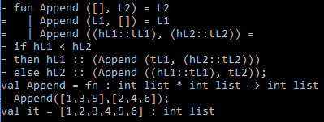

1. Translate Lisp to ML.  
   (defun mult (x)(cond ((null x) 1)

((consp x) (* (car x) (mult (cdr x))))))

(print (mult '(4 5 6)))  
  
ML:  
**fun mult ([]) = 1**

**| mult (hL :: tL) = hL * mult(tL);**

1. ML program that outputs list of first elements of every list of tuples.  
   **fun first ([]) = []**

**| first ((e1, e2) :: tL) = e1 :: first(tL);**  
  
first([1, “How”), (2, “Are”), (3, “you”)]);  
val it = [1,2,3] : int list  
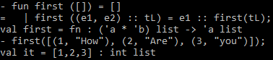

1. ML program to produce n-th Fibonacci number.  
   **fun Fib (n) =**

**if n < 3 then 1**

**else Fib(n-1) + Fib(n-2);**  
  
